**Thank you for downloading the Synthavali Texture!**  
This is a step by step guide to make your kitavali turn into a SynthAvali!   
It is meant for anyone at any level of unity knowledge.  
  
**Prerequisites**  
Of course, you will need the correct version of the unity editor to upload to VRchat. At the time of writing the current version for this is 2019.4.31f1. you can check the current version at any time in the VRchat docs: https://creators.vrchat.com/sdk/current-unity-version/  
  
Before we start you will need the following things to be already imported into your project.  
If you set up your project with VCC, you’ll need to add “Gesture manager” and “Avatars 3.0 manager” to the list of packages installed, and not install them manually. Keep in mind that VCC already installs the VRCSDK, do not install it manually if you are using VCC  
  
**Necessary packages (Please import in this order)**

The current VRCSDK. This comes with VCC, if you’re not using VCC you can download it from the same page:  
<https://vrchat.com/home/download>

Gesture manager (this can be added via VCC by default) it will be used to test the avatar before uploading  
<https://github.com/BlackStartx/VRC-Gesture-Manager/releases>

Avatars manager 3.0 (this can be added via VCC by default) it will be used for adding the parameters and animation layers to the avatar  
<https://github.com/VRLabs/Avatars-3.0-Manager/releases>

Poiyomi shader 8.1  
<https://github.com/poiyomi/PoiyomiToonShader/releases>

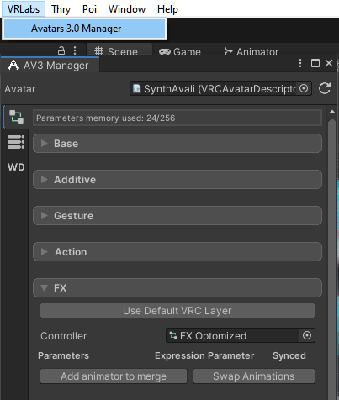  
Kitavali avatar. This can be found in the kitavali Server ( <https://discord.gg/kitavali> ) under #kitavali-avatar-templates <https://discord.com/channels/617637133926006794/1065115639771050054>  
  
And finally, the Synthavali unitypackage, that was provided along with this guide.  
  
**First steps**

Open the scene “Synthavali” in Assets>Woolier>Synthavali  
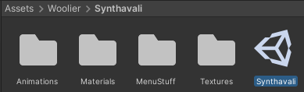  
Next up, open “Avatars 3.0 manager” under VRLabs

Select or drag SynthAvali in the avatar slot, scroll down to   
”FX” and expand it. Click “add animator to merge” and then   
Select the animator “FXSynth” and click “Merge on current”  
  
Then swap to the parameters tab (the three lines with dots)  
and on “parameters to copy” select “SynthavaliParameters”  
Then click “Copy parameters”  
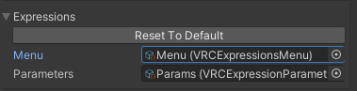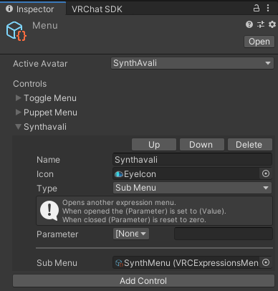**Adding the menu**  
  
Next up select your avatar and in the inspector, scroll down to “Expressions” and open “Menu”  
  
Once open, click “Add Control” and change the settings of the control to be the following:  
  
Name: (whatever you wish, by default “Synthavali”)

Icon: EyeIcon  
Type: Sub Menu  
Parameter: [None]  
Sub Menu: SynthMenu  
  
**Testing**

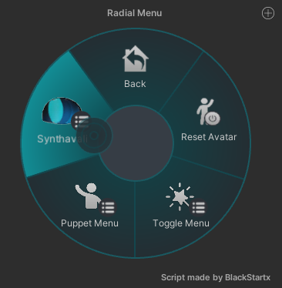If you wish to Test your avatar to see if it works just fine  
Before uploading, click “GestureManager” in your  
Hierarchy and then click on the play icon on top  
you’ll be greeted by a radial menu on your right, to test  
Your avatar!

**Uploading**

Your avatar should be ready to upload! Get out of play mode, and use the VRCSDK control panel to upload.   
  
Once you’re done uploading your avatar to PC, you can upload the quest avatar (it is disabled by default in the hierarchy, select it and turn it on)

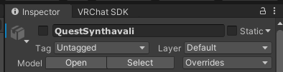

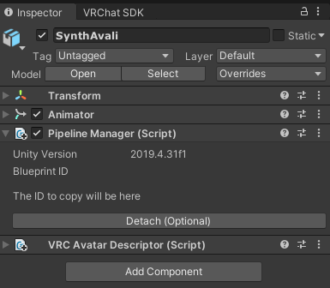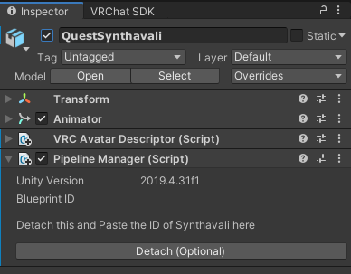After switching to quest, you should be able to upload the quest version as well! Just make sure to copy the blueprint ID from thePC version and paste it in the quest version, or they will be two separate avatars!